“Hire a Professional”

By

Jobanpreet Singh

Level-6

Final Project

Table of Contents

Client Detail…………………………………………………………………………………3

Project Proposal 3

Goals and Objectives 3

Project Scope 3

Project Specifications 3

Target Audience 3

Project Deliverables 4

Resource Requirements 4

Project Tasks and Milestones 4

Project Assumptions 5

Project Report 5

Non- Functional 5

Detail Design 6

Home Page 6

News Page 6

Registration Page 7

Clients Page Admin View 7

Professional Page Admin View 7

Professional Page Client View 8

Project Testing 9

User Manual 9

Summary 9

System Configuration 9

User Access Levels 9

# 

# Client Detail

|  |  |
| --- | --- |
| Client Name | Pushpinder Singh |
| Email Address | Pushpinder123@gmail.com |
| Phone | 028334543 |
| Developer | Joban |
| Company Name | Hire a Professional |

# Project Proposal

## Goals and Objectives

This project aims to implement an online web application named “Hire a Professional”. With the help of this application one can hire a professional easily and cost effectively. In this application, there are admin and client. Admin can register new professionals, view their profile, edit and delete them. Admin can also edit, delete and access details of the registered clients. Moreover, admin can edit, delete and access details of the hired professionals. Clients can view profiles of professionals and can hire them if they are available. New clients can signup for the application for free. Admin can register new data admin for the site. With the help of this application one can have a professional easily to do their day to day household tasks.

## Project Scope

The scope of this project is to implement an app named “Hire a Professional” with the help of which user can hire best professional to do their work. The duration of the project is 20 working days which is equals to 4 weeks.

## Project Specifications

* Login/Logout by admin and clients.
* Add, edit,deleteand check details of professionalsby admin
* Admin can edit, delete and check details of the clients.
* Admin can register new admins.
* Admin can edit, delete and access details of the hired professionals.
* Clients can view profiles of the professionals and can hire them.
* New Clients can sign up for the app.

## Target Audience

The age can be from 18 years to maximum can go 100 plus or more. The audience for this project is the people who are keen to take help from professional to do their work fast and effectively.

## Project Deliverables

The deliverables of the project are:

|  |  |
| --- | --- |
| **Deliverable** | **Description** |
| Final Report | This is the final report |
| Coding and implementation | The coding will go in this. The executable code of the project. |
| Documentation | This depicts the documentation of the project. |
| Testing | All the test details will be covered in this part. |

## Resource Requirements

The technologies used in this project are as follows:

* Asp.net MVC Framework
* 64-bit Processor and 4 GB or more RAM
* Identity framework- ASP
* Windows Operating System- 10
* Microsoft word for documentation.
* Microsoft Excel.

## Project Tasks and Milestones

The table below shows the Project Tasks and Milestones

|  |  |
| --- | --- |
| **Tasks** | **Weeks** |
| Research and analysis | 1-2 |
| Planning and first kick of meeting Project Proposal document. | 1-2 |
| Design of Database | 2-3 |
| UI design | 2-3 |
| Implementationof Identity Framework | 2-3 |
| Coding for admin and Client | 3-4 |
| Testing | 3-4 |
| Final Documentation | 3-4 |

## Project Assumptions

While doing the implementation, following assumption are made:

* One admin and client will be there to login when the app will be designed and implemented.
* Admin can only register new admin if he/she will be signing first.
* App will be open source.

# Project Report

#### Functional and Non-Functional

The functional requirements and non-functional requirements of this projectareas follows:

|  |  |
| --- | --- |
| Users | Functional |
| Admin | * Manage professionals, add, edit, delete and check details. * Login/Logout * Register new data admins * Edit, delete and check details of the clients. * Edit, delete and access details of the hired professionals. |
| Clients | * View Profiles of the Professionals. * Hire a Professional. * New clients can signup * Login using valid credentials |
| Non- Functional | | |
| * Project will be compatible on all browsers and devices. * Security and fast load time of the project. * High performance and limited access for the clients. | | |

## Detail Design

### Home Page

This page is the main landing page of the application. In this page on the navigation menu there are options- Registered Professionals, Client Signup, register a data admin and login. Moreover, a button start hiring a professional is also present in the header images, which when click shows the list of the available professionals.



### News Page

With the help of this page admin and client can login into the web application by using their credentials. This page is common to admin and client.

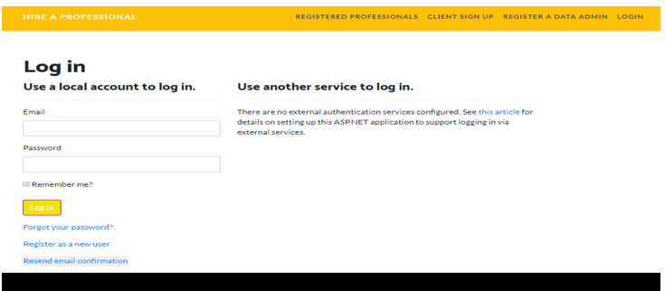

### Registration Page

With the help of this page admin can register new data admin for the web application.

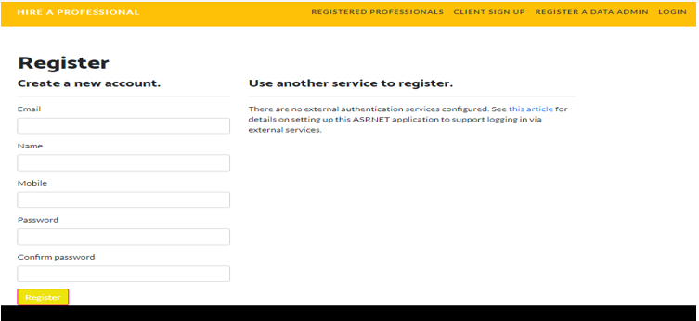

### Clients Page Admin View

This page shows the various clients registered with the app. Admin has the right to manage the existing ones by editing, deleting and checking their details. 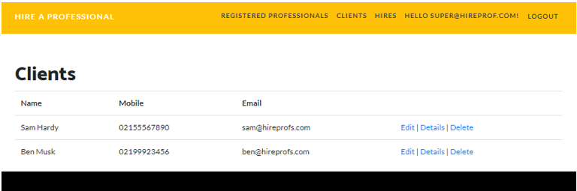

### Professional Page Admin View

This page shows the available professionals. Admin can register new professionals, edit, delete and access profiles of the existing ones.

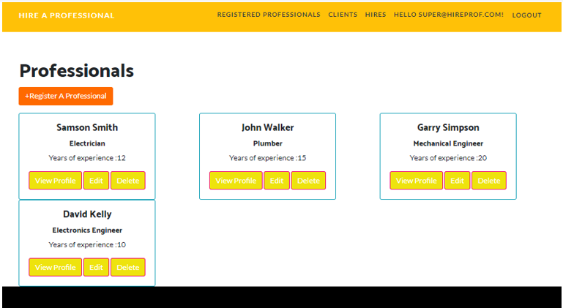

### Professional Page Client View

This page shows the client view of the professionals. As a client one can view the profiles of the professionals and book them if they are available.

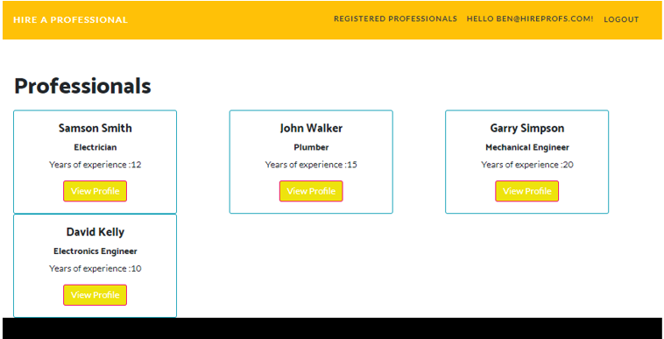

## Project Testing

Excel File Attached for Usability Testing can be found at [Hire a Professional.xls](Hire%20a%20Professional.xls)

# User Manual

With the help of “Hire a Professional” application one can hire a professional easily and cost effectively. In this application, there are admin and client. Admin can register new professionals, view their profile, edit and delete them. Admin can also edit, delete and access details of the registered clients. Moreover, admin can edit, delete and access details of the hired professionals. Clients can view profiles of professionals and can hire them if they are available. New clients can sign up for the application for free. Admin can register new data admin for the site. With the help of this application one can have a professional easily to do their day to day household tasks.

## Summary

### System Configuration

Hire a Professional app will be useful to hire a good professional at your fingertips.

### User Access Levels

Only registered users can access the features of Hire a Professional application

* **Admin:**Admin has full access of the app can register new admins.
* **Clients:**All clients are having limited access and all clients are managed by the admin. Newclients can register themselves.

**Appendix 3**

**Client Review Form**

My developer’sname: Joban Singh

This form is intended to let you review the communication skills of your developer for this assignment. Your review will partly count towards their final mark. Do not take into account technical skills.

# Grading scale

You must grade your developer for each item listed in the tables below. 1 being the lowest, 5 the highest.

|  |  |  |  |  |
| --- | --- | --- | --- | --- |
| **1** | **2** | **3** | **4** | **5** |
| Strongly disagree | Disagree | Ok | Agree | Strongly agree |

# Review your developer

|  |  |  |
| --- | --- | --- |
| **Item** | **Grade** | **Comment** |
| Communicated clearly and effectively | 4 |  |
| Kept you informed of the progress | 5 |  |
| Met timelines | 4 |  |
| Responded promptly to problems | 4 |  |
| Met overall project objectives | 4 |  |
| Was open to new ideas and suggestions | 4 |  |
| Was easy to work with | 5 |  |

Comments

Provide any extra comments on your developer’s communication skills and professionalism.

Phuspinder is very good in nature and coding style is very professionalism

## Signed by Client

|  |  |
| --- | --- |
| **Signature: Phuspinder Singh** | **Date: 18-nov-2021** |
| **Name: Phuspinder Singh** | **Title: Hire Proffesional** |
| **Contact details (email/Tel):** | |

Client Meeting:

|  |
| --- |
| Meeting Details |
| * Date and time: 29-Oct-2021 * Location: New Zealand |
| Attendees: Developer Jobanpreet Singh and Client Phuspinder Singh |
| Agenda: Discussion of Hire Professionals |
| Discussion (Important Points): Database and Tables, structure and all around Work |
| My To Dos (Actions):I shown roughly prepared files of database and tables for the approval |
| Questions requiring Follow- Up: According to requirement some changes occurred |
| Comments: Satisfied with work already done |
| Next meeting  Date and Time: 4- Nov-2021 3:00 Pm  Location: New Zealand  Agenda: Show Progress of the started work |

## Task 9- Project management

First experience went very well it was an experience with bundle of learning the professionalism of coding and understanding the concept of working alone on an Practical live project because dealing with client talking and understanding the requirement is also a Big task but on my side it was not difficult because client understand about the situation and make me understand very frankly.

AS I prepared my task before the meeting and they approved it with few changes and so everything went very well then worked on creating tables and structure

# Time

From the staring day to finish the project it took more than 40 days to complete the project my design part took less time as client was more focused on functionalities part.

# Difficulties

As client as was more focused on functionalities part so I need pay more attention towards it because I need fulfil his requirements and arranging the tables in order to connect with each other was a difficult task for me.

# Learning’s

From starting to through out the project i learned following points :

* Understanding the Client Requirement
* Work on Mock-ups
* Designing the database
* Finalizing the things